Final Project Milestone 1: Proposal and Mockups

Course: User Interface Design in App Development
Team Members:
Meet Ahalpara,
Samarth Patel,
Pratik Hirapara,
Devang Pandit

Professor: Marwan Farah
Date: 19 March 2026

Table of Contents
Final Project Milestone 1: Proposal and Mockups 1
1. Introduction 3
2. Purpose of the Application 4
3. Main Features of the Application 5
4. Target Users 6
5. Application Screens (Mockups) 6
5.1 Mockup 1 – Main Dashboard Screen 7
5.2 Mockup 2 – Add / Edit Appointment Screen 9
5.3 Mockup 3 – Appointment Details Screen 11
6. Application Workflow 13
7. Database Integration Plan 13
8. Accessibility Considerations 14
9. Testing Plan 14
10. Conclusion 15
References 16

1. Introduction

The proposed final project is a JavaFX application named Health Appointment Tracker. The purpose is to help patients, caregivers, and medical office staff record, monitor and manage medical appointments in an organized way.
Managing health appointments is often fragmented across phone calls, reminder cards, and disconnected mobile apps. This application provides a single system where users can store patient information, schedule appointments with specific doctors, track appointment statuses, and record clinical notes.
The application follows a CRUD-based design, which means users can:
- Create new appointment records
- Read and review scheduled and past appointments
- Update appointment details and statuses
- Delete cancelled or outdated records

This project is expanding the application developed in Assignment 2. The earlier version stored appointment data only in memory using an ObservableList, tracking fields such as patient ID, patient name, date, time, doctor, and condition. For the final project, the system will be improved by integrating a database, allowing appointment records to be stored permanently, and by adding advanced features such as patient profile management, appointment status tracking, and clinical notes.

2. Purpose of the Application
The main purpose is to provide a simple and structured system for managing medical appointments and patient records.
The application allows users to store important information about each appointment including the attending doctor, medical condition, appointment time, and status. It also allows users to record clinical notes and follow-up instructions after each visit.
By storing this information in a database, users will be able to return to the application later and continue managing appointment records without losing any previous data.
This project helps demonstrate several programming skills including:
- JavaFX GUI development
- CRUD operations
- database integration
- input validation
- user interface design
- application workflow design

3. Main Features of the Application
The Health Appointment Tracker will include several features to help users manage appointment records effectively.
The main features of the system include:
- Creating new appointment records
- Viewing all stored appointment records
- Updating appointment details and statuses
- Deleting appointment records
- Searching for appointments by patient name, ID, or doctor
- Filtering appointments by doctor, condition, status, or date range
- Viewing detailed information about each appointment
- Tracking appointment status through the full lifecycle: Scheduled, Confirmed, In Progress, Completed, Cancelled, and No-Show
- Recording pre-visit notes and post-visit clinical notes for each appointment
- Managing patient profiles with contact details, blood type, allergies, and medical history
- Assigning appointments to specific doctors and departments
- Storing insurance and billing information alongside each appointment record
- Displaying upcoming appointment reminders within a configurable time window
- Showing dashboard statistics including today's appointments, upcoming count, and completion rate
- Saving all records in a database for permanent storage

These features allow the application to function as a complete appointment and patient management system.

4. Target Users
The application is designed for anyone who needs to manage medical appointments.
Possible users include:
- medical receptionists and administrative staff at clinics or family practices
- individual patients who want to track their own appointments and medical history
- caregivers managing appointments for family members such as elderly parents or children
- small independent medical practices that need a lightweight desktop scheduling tool

The application focuses on simplicity so that users can easily add and manage appointment records without unnecessary complexity.

5. Application Screens (Mockups)
The three main screens have been designed for the application. These screens represent the main scenes of the user interface.
The mockups illustrate how users will interact with the system.
The screens are shown in:
- Mockup 1 – Main Dashboard Screen
- Mockup 2 – Add / Edit Appointment Screen
- Mockup 3 – Appointment Details Screen

5.1 Mockup 1 – Main Dashboard Screen

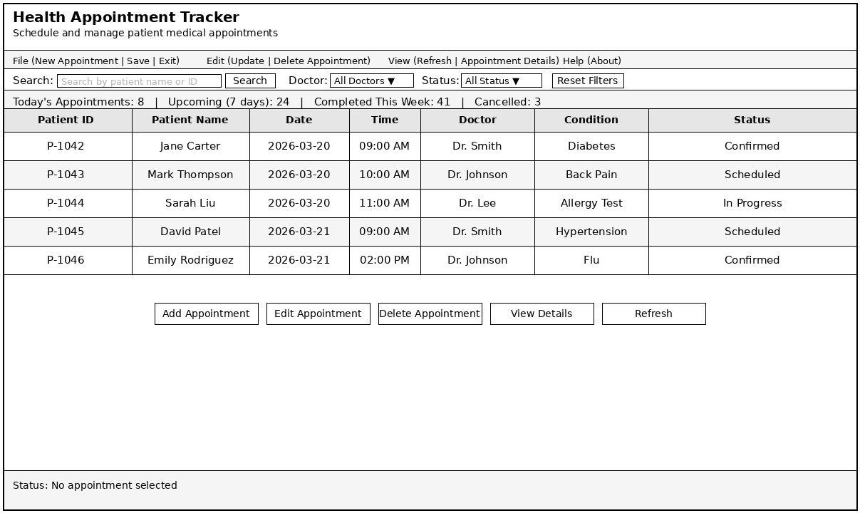

The Main Dashboard Screen acts as the central interface of the application. It displays all appointment records stored in the system and allows users to manage them. From this screen, users can perform most of the main actions of the application.
The top section of the screen includes the application title and a menu bar. The menu provides options such as creating new appointments, updating records, deleting records, refreshing the table, and viewing appointment details.
Below the menu is a search and filtering section. Users can search for appointments by patient name or ID and filter the table by doctor, appointment status, or date range. A reset button allows users to clear all active filters.
The center of the screen contains a TableView displaying appointment records. Each row represents an appointment entry and includes information such as patient ID, patient name, date, time slot, assigned doctor, medical condition, and appointment status.
Below the table are several action buttons including:

- Add Appointment
- Edit Appointment
- Delete Appointment
- View Details
- Refresh

These buttons allow users to quickly perform CRUD operations.
At the bottom of the screen, a status message area provides feedback about the current state of the application. For example, Status: No appointment selected.

5.2 Mockup 2 – Add / Edit Appointment Screen

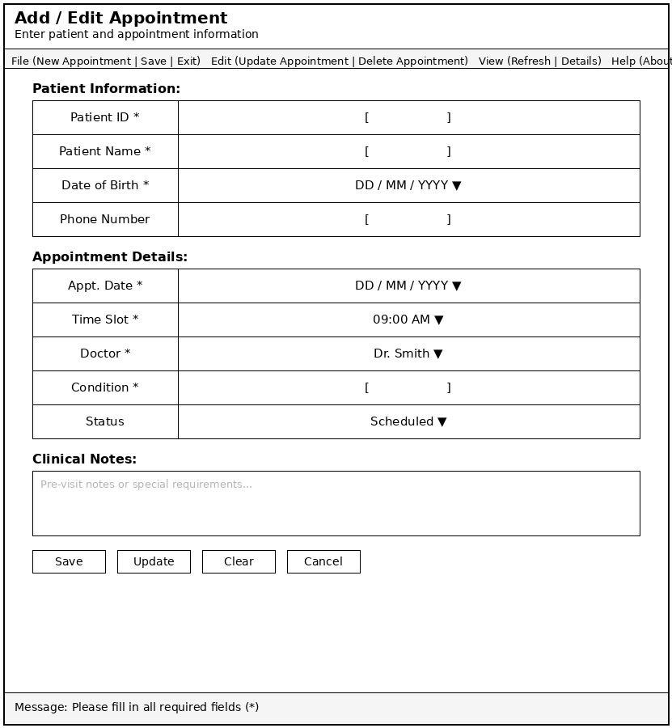

The Add / Edit Appointment Screen allows users to create a new appointment record or modify an existing one. This screen contains a structured form where users can enter information about the patient, the appointment, and any associated clinical notes.
The form is divided into several sections. The Patient Information section includes fields for:

- Patient ID
- Patient Name
- Date of Birth
- Phone Number

These fields identify the patient associated with the appointment.
The Appointment Details section allows users to schedule and configure the appointment. This section includes fields for:

- Appointment Date
- Time Slot
- Attending Doctor
- Medical Condition or Reason for Visit
- Appointment Status

The Appointment Status field uses a drop-down menu with values including Scheduled, Confirmed, In Progress, Completed, Cancelled, and No-Show.
The Clinical Notes section includes a text area where users can record pre-visit notes, special patient requirements, or any other relevant information about the appointment.
At the bottom of the screen are action buttons:

- Save
- Update
- Clear
- Cancel

These buttons allow users to store new records or update existing ones.
A feedback message area displays validation messages when required fields are missing or contain invalid values.

5.3 Mockup 3 – Appointment Details Screen

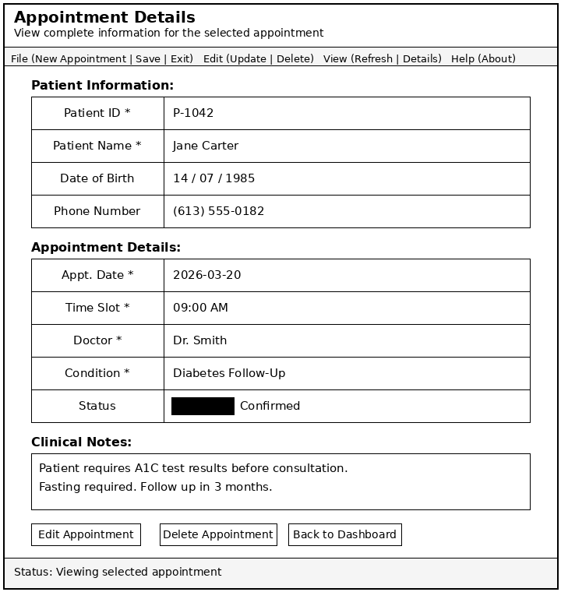

The Appointment Details Screen displays complete information about a selected appointment record. This screen allows users to review an appointment record without modifying it directly.
This screen displays three main sections. The Patient Information section shows the patient's ID, full name, date of birth, and contact phone number.
The Appointment Details section shows all scheduling information including date, time, assigned doctor, medical condition, and appointment status. The status is displayed prominently so that staff can quickly assess the state of the appointment.

For example:
Patient: Jane Carter - Appointment: 2026-03-20 at 09:00 AM - Dr. Smith - Status: Confirmed
The Clinical Notes section displays any pre-visit or post-visit notes recorded for this appointment.
At the bottom of the screen, users have access to navigation buttons:
- Edit Appointment
- Delete Appointment
- Back to Dashboard

These buttons allow the user to either modify the record or return to the main dashboard.

6. Application Workflow

The application follows a clear workflow that supports the full CRUD process.
The main workflow begins on the Main Dashboard. From there, users can open the Add / Edit Appointment screen to create or modify records. They can also open the Appointment Details screen to review complete information about a specific appointment.
The overall workflow can be described as:
Dashboard -> Add / Edit Appointment -> Appointment Details -> Back to Dashboard
This workflow ensures that users can easily move between viewing records, editing records, and reviewing detailed information.

7. Database Integration Plan

In Assignment 2, appointment records were stored only in memory using an ObservableList. This meant that all data was lost when the application closed.
For the final project, the application will be expanded to include Azure SQL Database as a cloud-based database solution. Instead of storing data only during runtime, appointment records will be saved in an online database so that records remain available even after the application is closed and can be accessed again in further sessions.
The database table will store information such as:

- Patient ID
- Patient Name
- Appointment Date
- Time Slot
- Attending Doctor
- Medical Condition
- Appointment Status
- Clinical Notes

The JavaFX application will communicate with the database to insert, retrieve, update, and delete records.

8. Accessibility Considerations

Accessibility is an important part of user interface design.
The application will include several accessibility improvements such as:
- clearly labeled input fields
- logical keyboard navigation between controls
- readable font sizes
- clear visual feedback messages
- consistent layout for easier navigation

These design decisions help ensure that the application is easier to use for different types of users, including medical staff who may be entering records quickly during a busy clinic day.

9. Testing Plan

Testing will be performed to ensure that the application works correctly.
Testing will focus on:
- verifying that CRUD operations work properly for appointment records
- validating user input fields including date, time, and required text fields
- confirming that database records are correctly saved and retrieved
- checking that navigation between screens works correctly
- ensuring that search and filtering features function properly
- verifying that appointment status updates are correctly reflected in the TableView

These tests will help confirm that the application behaves as expected.

10. Conclusion

The Health Appointment Tracker project builds on the CRUD-based JavaFX application developed in Assignment 2.
For the final project, the system will be expanded by integrating a database and adding additional features such as appointment status tracking, clinical notes, patient profile management, and advanced search and filtering. The mockups created for Mockup 1, Mockup 2, and Mockup 3 define the structure and workflow of the application. These designs provide a clear plan for the final development stage.
The next phase of development will focus on implementing database storage, building the full multi-screen interface, improving data management, and completing the appointment management system.

References

[1] | "JavaFX Tutorial," Geeksforgeeks, 15 10 2025. [Online]. Available: https://www.geeksforgeeks.org/java/javafx-tutorial/. [Accessed 19 03 2026].
[2] | "Implementing JavaFX Best Practices," ORACLE, 01 2014. [Online]. Available: https://docs.oracle.com/javafx/2/best_practices/jfxpub-best_practices.htm. [Accessed 19 03 2026].
[3] | "Top 10 JavaFX UI Design Patterns," JavaFX Tips, [Online]. Available: https://javafx.tips/article/Top_10_JavaFX_UI_Design_Patterns.html. [Accessed 19 03 2026].
[4] | R. Fadatare, "JavaFX JDBC MySQL Tutorial," Java Guides, [Online]. Available: https://www.javaguides.net/2019/07/javafx-jdbc-mysql-tutorial.html. [Accessed 19 03 2026].
[5] | I. Hub, "Complete JavaFX CRUD Tutorial with MySQL Database Integration | Step-by-Step Guide," YouTube, 01 05 2024. [Online]. Available: https://www.youtube.com/watch?v=1vByWUaM1-k. [Accessed 19 03 2026].
[6] | tookootek, "JavaFX Tutorial | JavaFX Connect to MySQL Database (2021) - Basic Demo," YouTube, 21 02 2021. [Online]. Available: https://www.youtube.com/watch?v=whhSR0wlWQY. [Accessed 19 03 2026].
[7] | K. PH, "JavaFX SQLite Database CRUD Tutorial | JavaFX Notes App," YouTube, 11 05 2024. [Online]. Available: https://www.youtube.com/watch?v=N_YZZVSLaIs. [Accessed 19 03 2026].

